Week 4
Homology reduction
I try to reduce my dataset by checking the homology in cd.hit.
The total amount of proteins is 5791.
With 90% sequence identity cut-off it is reduced of 25 sequences.
With 75% homology the reduction is of 147 proteins.
With 50% homology the reduction is of 515 proteins.
Then I try another approach to try to reduce my dataset.
Total number of amino acids: 17373.
Total number of sequences: 5791
I create a script (prot_analysis) that calculates how many sequences only contains G, which are 3597 and proteins that have a signal peptide: 2194. The average length of signal peptide is 23,5 residues.

I have tried another approach to reduce the dataset, I have only included the first 70 residues of each sequence. The dataset has been reduced almost 7 fold.
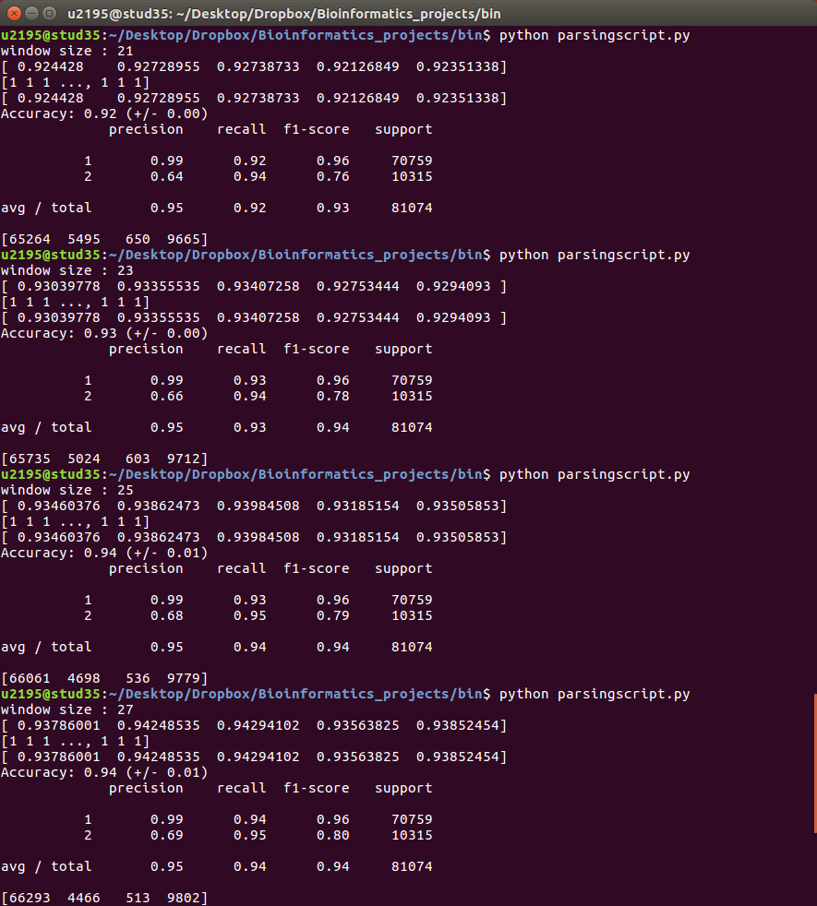
Now I run my svm with this reduced dataset (70aadata.txt) and I try to optimize the accuracy of prediction by changing the window size:
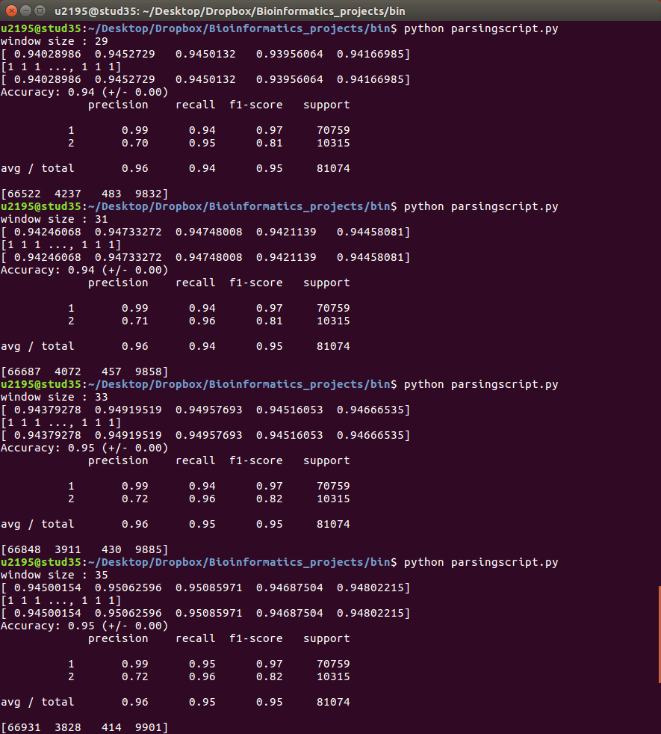

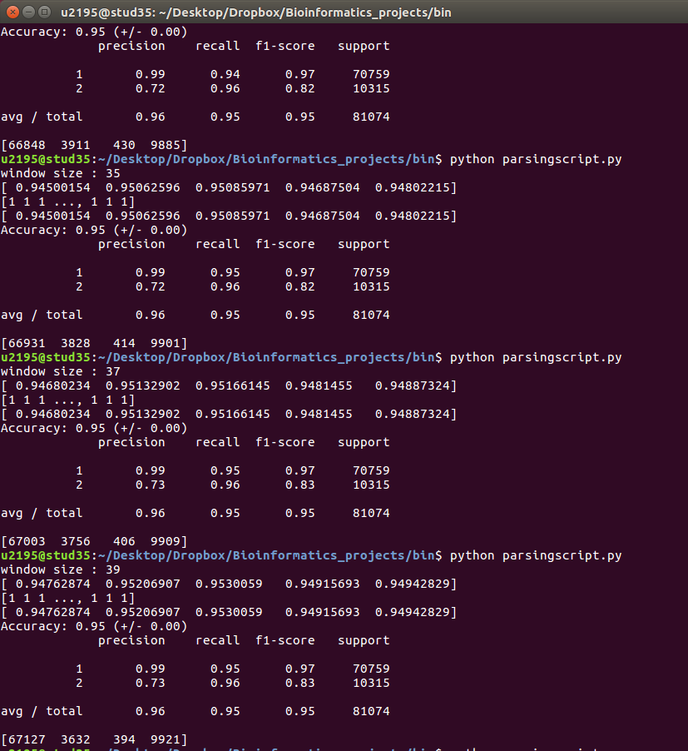

Window size =41 I get memory error

Friday 10th March
Modified the scores, now they are correct. Optimize window size:
